Bahria University,

Karachi Campus



LAB EXPERIMENT NO.

**10**

LIST OF TASKS

|  |  |
| --- | --- |
| TASK NO | OBJECTIVE |
| **1** | **Write a Python program that utilize Euler’s method for IVP: 𝑦′ = 2 − 𝑒 −4𝑡 − 2𝑦 with y(0) = 1, step size of h=0.1 to find approximate values of the solution at t = 0.1, 0.2, 0.3, 0.4,and 0.5.** |
| **2** | **Write a Python program that utilize improved Euler’s method for IVP: 𝒚′ = − 𝟏/𝟐 𝒆 𝒕 /𝟐 𝐬𝐢𝐧(𝟓𝐭) + 𝟓𝒆 𝒕/𝟐 𝐜𝐨𝐬(𝟓𝐭) + y with y (0) = 0, to find approximate values of the solution at t = 1, t = 2, t = 3, t = 4, and t = 5. Use h = 0.1, h = 0.05, h = 0.01, h = 0.005 and h = 0.001 for the approximations.** |
|  |  |

Submitted On:

**Date: 5/1/2024**

**Task No. 01:**

**Write a Python program that utilize Euler’s method for IVP: 𝑦′ = 2 − 𝑒 −4𝑡 − 2𝑦**

**with y(0) = 1, step size of h=0.1 to find approximate values of the solution at t = 0.1, 0.2, 0.3, 0.4,and 0.5.**

**(Output: 0.9, 0.852967995, 0.837441500, 0.839833779, 0.851677371)**

**Solution:**

import math

def function(x,y):

return 2-math.exp(-4*x)-2*y

def eulers_method(t0,tn,y0,h):

while(t0<tn):

y0+=h*function(t0,y0)

t0+=h

print('Approx solution: ',y0)

t0=0

y0=1

h=0.1

tn=[0.1,0.2,0.3,0.4,0.5]

for i in range(0,(len(tn))):

eulers_method(t0,tn[i],y0,h)

**Output:**

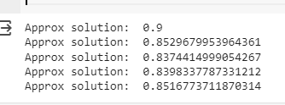

**Task No. 02:**

**Write a Python program that utilize improved Euler’s method for IVP: 𝒚′ = − 𝟏/𝟐 𝒆 𝒕 /𝟐 𝐬𝐢𝐧(𝟓𝐭) + 𝟓𝒆 𝒕/𝟐 𝐜𝐨𝐬(𝟓𝐭) + y with y (0) = 0, to find approximate values of the solution at t = 1, t = 2, t = 3, t = 4, and t = 5. Use h = 0.1, h = 0.05, h = 0.01, h = 0.005 and h = 0.001 for the approximations.**

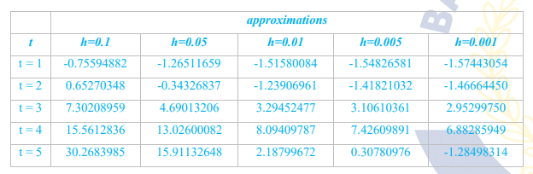

**Solution:**

Import math

def function(x,y):

return -(1/2)*math.exp(x/2)*math.sin(5*x)+5*math.exp(x/2)*math.cos(5*x)+y

def predictor_corrector_method(t0,tn,y0,h):

while(t0<tn):

t1=t0+h

p_y=y0+h*function(t0,y0)

c_y=y0+(h/2)*(function(t0,y0)+function(t1,p_y))

t0=t1

y0=p_y

return y0

t0=0

y0=0

h=[0.1,0.05,0.01,0.005,0.001]

tn=[1,2,3,4,5]

for i in range(0,(len(tn))):

print('At tn:',tn[i])

for j in range(0,len(h)):

print('Approx Solution at',h[j],':',predictor_corrector_method(t0,tn[i],y0,h[j]))

print('\n')

**Output:**

